Theme
How we can scale our experience, knowledge, and influence to help humanity

Related Topics
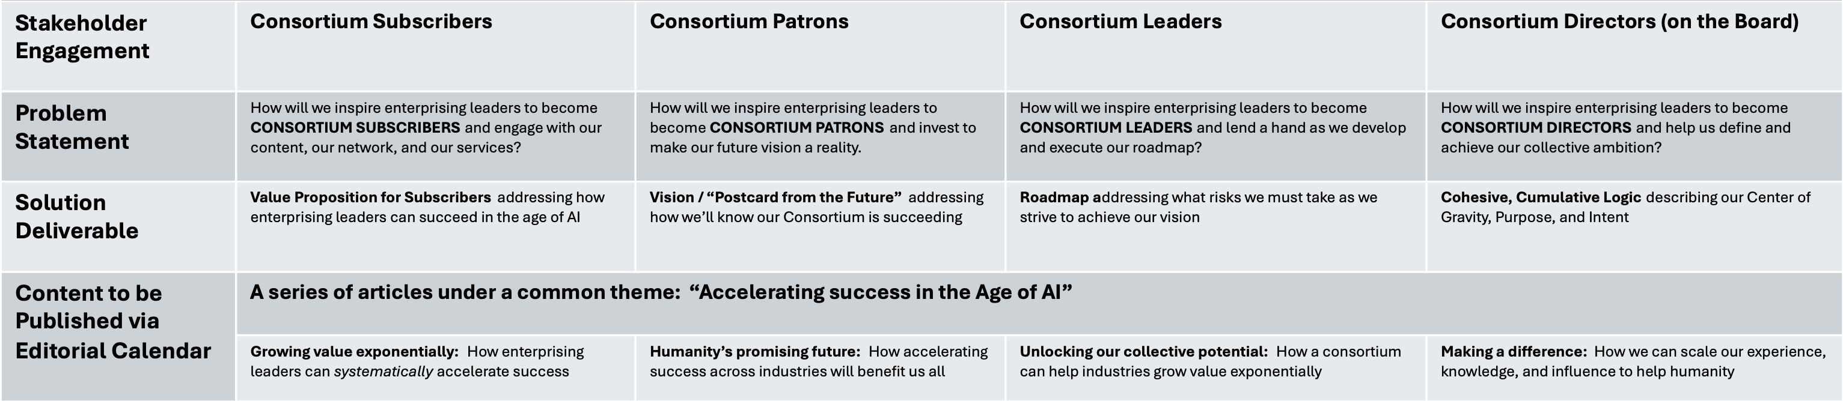

Outline

Draft

